EXPERIMENT 3: GREEDY ALGORITHMS IMPLEMENTATION & ANALYSIS
AIM
To design, implement, and analyze greedy approach algorithms by solving three standard computational problems with interactive user input: Fractional Knapsack Problem, Activity Selection Problem, and Maximum Events Attended (Greedy Interval Scheduling with Min-Heap).
THEORETICAL BACKGROUND
A greedy algorithm builds up a solution piece by piece, always choosing the next piece that offers the most immediate and local benefit (locally optimal choice) with the intent of reaching a global optimum. For a greedy strategy to guarantee a globally optimal result, the problem must exhibit two core properties:
- 1. Greedy-Choice Property: A globally optimal solution can be arrived at by making locally optimal (greedy) choices without reconsidering previously made decisions.
- 2. Optimal Substructure: An optimal solution to the overall problem contains within it optimal solutions to its subproblems.
Problem Breakdown:
•Part 1 — Fractional Knapsack: Items have weights and values. Fractions of items are permissible. The greedy choice selects items in descending order of value-to-weight ratio (v/w). This guarantees the maximum value within knapsack capacity W.
• Part 2 — Activity Selection: A set of n activities with start and finish times. To maximize the count of mutually non-overlapping activities, sort activities by earliest finish time. Selecting the activity that finishes earliest leaves maximum remaining time for subsequent activities.
• Part 3 — Maximum Number of Events Attended: Given events with [start, end] days, only one event can be attended per day. Sort events by start day, and for each day, greedily attend the active event having the earliest closing deadline (using a Min-Heap/Priority Queue).
ALGORITHMIC DESIGN & PSEUDOCODE
Part 1: Fractional Knapsack Algorithm
- Calculate ratio r_i = value_i / weight_i for all items i = 1 to n.
- Sort all items in descending order of ratio r_i.
- Initialize total_value = 0, remaining_capacity = W.
- Iterate through sorted items: if item weight <= remaining_capacity, take 100% of item. Else, take fraction (remaining_capacity / weight), add fraction * value to total_value, and terminate.
Part 2: Activity Selection Algorithm
- Sort activities in ascending order of their finish times f_i.
- Select the first activity (index 0) and set last_finish_time = f_0.
- Iterate through remaining activities: if start_time s_i >= last_finish_time, select activity i and update last_finish_time = f_i.
Part 3: Maximum Events Attended (Min-Heap Strategy)
- Sort events by their start day.
- Track current day d, starting from the minimum start day to maximum end day.
- Push end days of all events starting on day d into a min-priority queue.
- Discard events from the priority queue whose end day < d (expired).
- If the queue is non-empty, pop the event with earliest end day, attend it, and increment count.
IMPLEMENTATION CODE
Part 1: Fractional Knapsack Algorithm
import java.util.*;

public class AssignCookies {
public static int findContentChildren(int[] greed, int[] cookies) {
Arrays.sort(greed);
Arrays.sort(cookies);

int child = 0;
int cookie = 0;

while (child < greed.length && cookie < cookies.length) {
if (cookies[cookie] >= greed[child]) child++;
cookie++;
}

return child;
}

public static void main(String[] args) {
Scanner sc = new Scanner(System.in);
System.out.print("Enter number of children: ");
int n = sc.nextInt();
int[] greed = new int[n];

System.out.println("Enter greed factor of each child:");
for (int i = 0; i < n; i++) {
greed[i] = sc.nextInt();
}

System.out.print("Enter number of cookies: ");
int m = sc.nextInt();
int[] cookies = new int[m];

System.out.println("Enter cookie sizes:");
for (int i = 0; i < m; i++) {
cookies[i] = sc.nextInt();
}

int result = findContentChildren(greed, cookies);
System.out.println("Maximum number of content children: " + result);

sc.close();
}
}

Part 2: Activity Selection Algorithm
import java.util.*;

public class NonOverlappingIntervals {
public static int eraseOverlapIntervals(int[][] intervals) {
if (intervals.length == 0) {
return 0;
}

// Sort by ending time
Arrays.sort(intervals, (a, b) -> Integer.compare(a[1], b[1]));

int selected = 1;
int lastEnd = intervals[0][1];

for (int i = 1; i < intervals.length; i++) {
// Non-overlapping interval
if (intervals[i][0] >= lastEnd) {
selected++;
lastEnd = intervals[i][1];
}
}

// Number of intervals that must be removed
return intervals.length - selected;
}

public static void main(String[] args) {
Scanner sc = new Scanner(System.in);
System.out.print("Enter number of intervals: ");
int n = sc.nextInt();
int[][] intervals = new int[n][2];

System.out.println("Enter start and end time of each interval:");
for (int i = 0; i < n; i++) {
System.out.print("Interval " + (i + 1) + ": ");
intervals[i][0] = sc.nextInt();
intervals[i][1] = sc.nextInt();
}

int result = eraseOverlapIntervals(intervals);
System.out.println("Minimum number of intervals to remove: " + result);

sc.close();
}
}

Part 3: Maximum Events Attended (Min-Heap Strategy)
import java.util.*;

public class MaximumNumberOfEvents {

public static int maxEvents(int[][] events) {

// Sort events by starting day
Arrays.sort(events, (a, b) -> Integer.compare(a[0], b[0]));

PriorityQueue<Integer> minHeap = new PriorityQueue<>();

int n = events.length;
int i = 0;
int day = 0;
int attended = 0;

while (i < n || !minHeap.isEmpty()) {

// If no active events, jump to the next event's start day
if (minHeap.isEmpty()) {
day = Math.max(day, events[i][0]);
}

// Add all events that have started
while (i < n && events[i][0] <= day) {
minHeap.add(events[i][1]);
i++;
}

// Remove events that have already expired
while (!minHeap.isEmpty() && minHeap.peek() < day) {
minHeap.poll();
}

// Attend the event that ends earliest
if (!minHeap.isEmpty()) {
minHeap.poll();
attended++;
day++;
}
}

return attended;
}

public static void main(String[] args) {

Scanner sc = new Scanner(System.in);

System.out.print("Enter number of events: ");
int n = sc.nextInt();

int[][] events = new int[n][2];

System.out.println("Enter start and end day of each event:");

for (int i = 0; i < n; i++) {
System.out.print("Event " + (i + 1) + ": ");
events[i][0] = sc.nextInt();
events[i][1] = sc.nextInt();
}

int result = maxEvents(events);

System.out.println("Maximum number of events that can be attended: " + result);

sc.close();
}
}

SAMPLE TEST CASES & RESULTS
Part 1: Fractional Knapsack Test
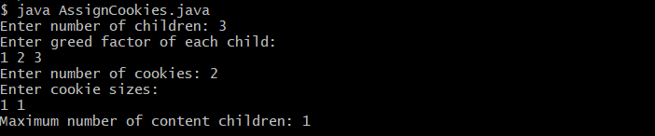
Part 2: Activity Selection Test
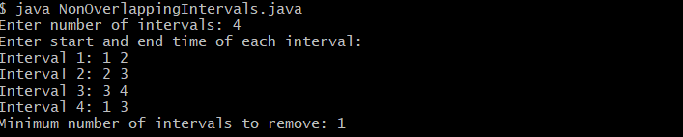
Part 3: Maximum Events Attended Test
